1. CREATED DATABASE NAMED SAMPLEDB AND CREATED TABLE

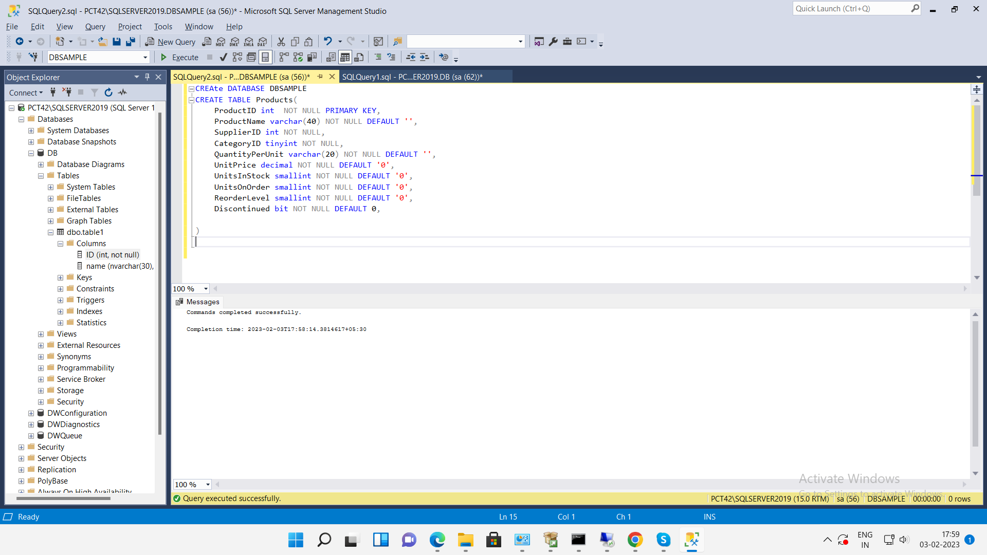

2. INSERTION OF SAMPLE DATA INTO TABLE SO WE CAN RUN QUERY ON IT

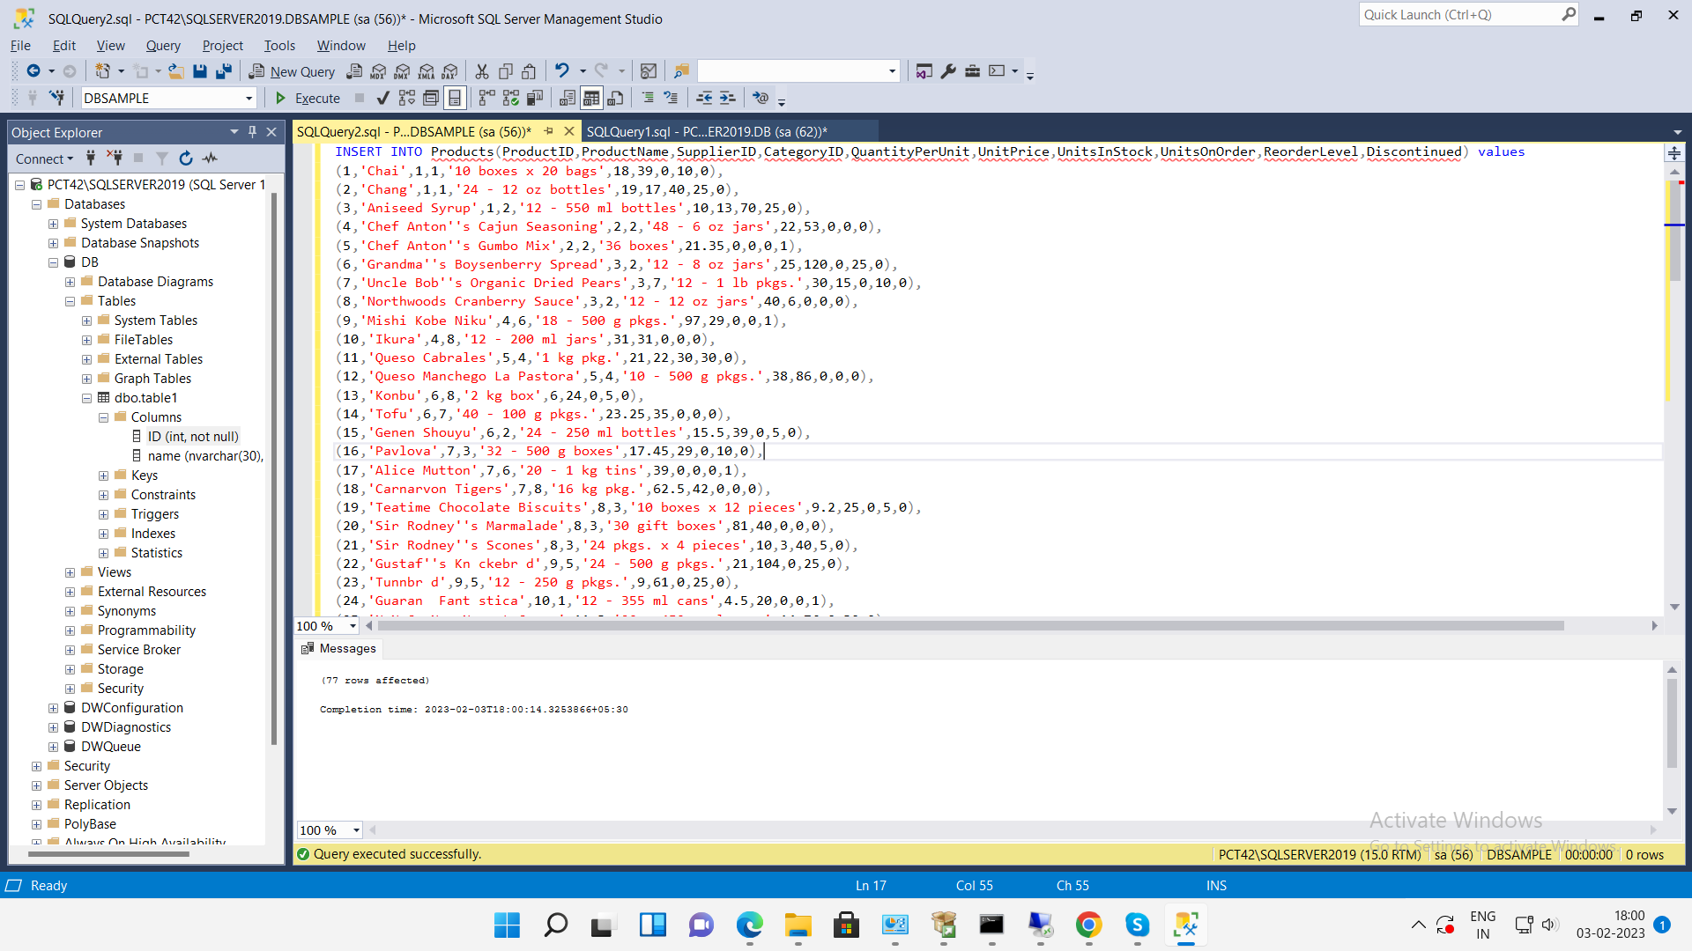

3. a query to get a Product list (id, name, unit price) where current products cost less than $20.

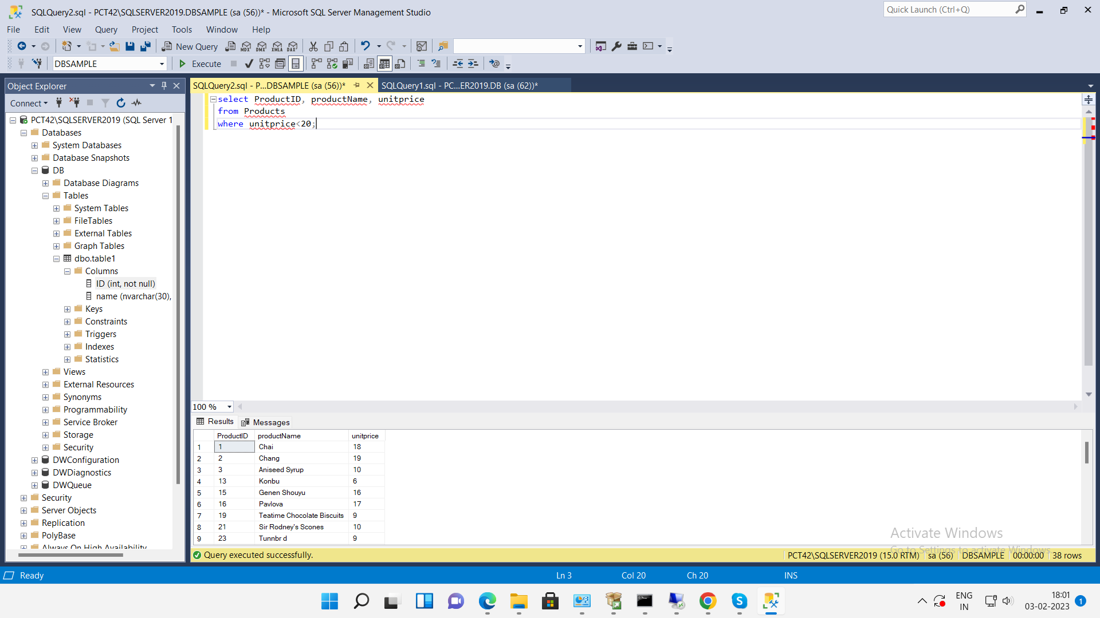

4. a query to get Product list (id, name, unit price) where products cost between $15 and $25

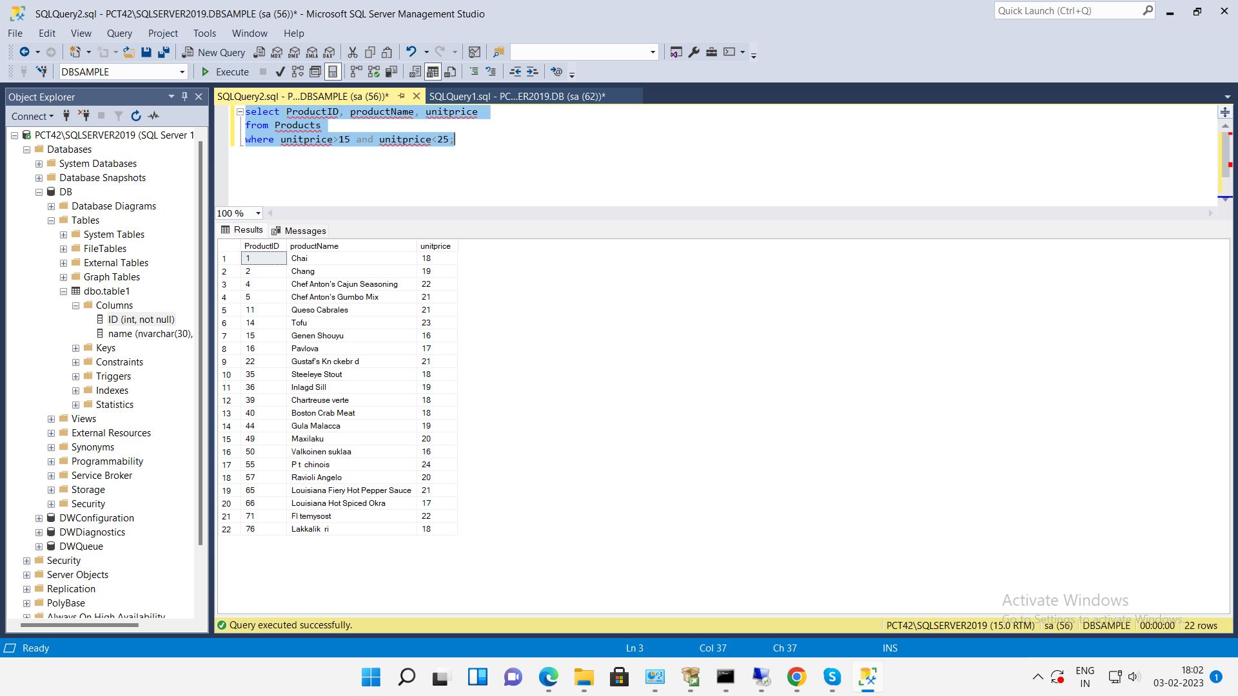

5. query to get Product list (name, unit price) of above average price

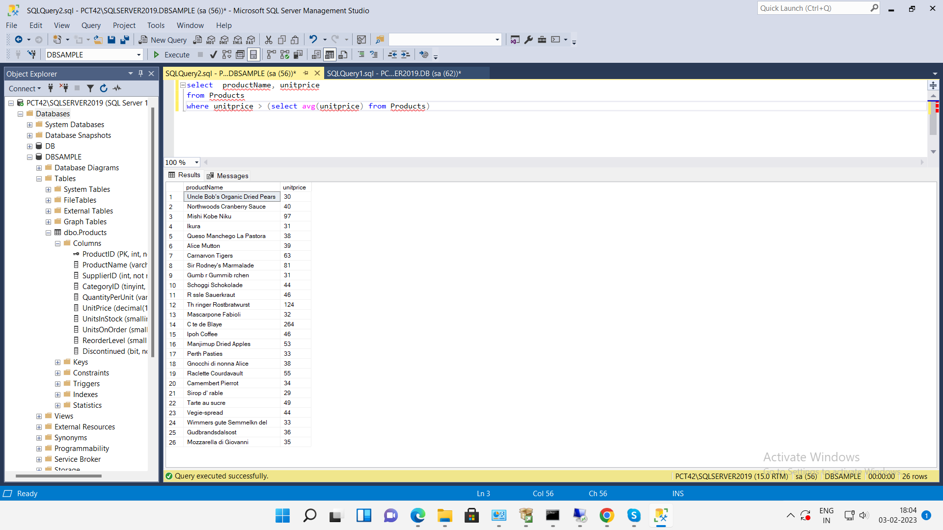

6.query to get Product list (name, unit price) of ten most expensive products

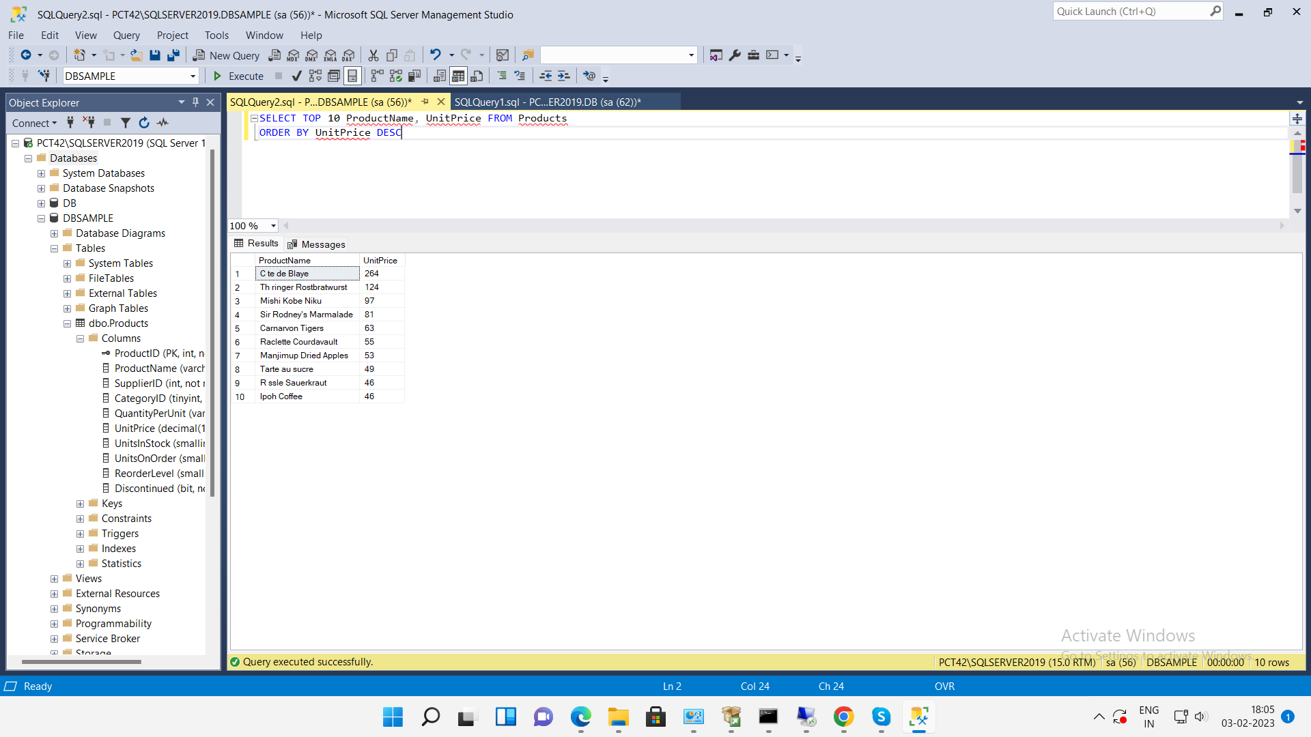

7. query to count current and discontinued products

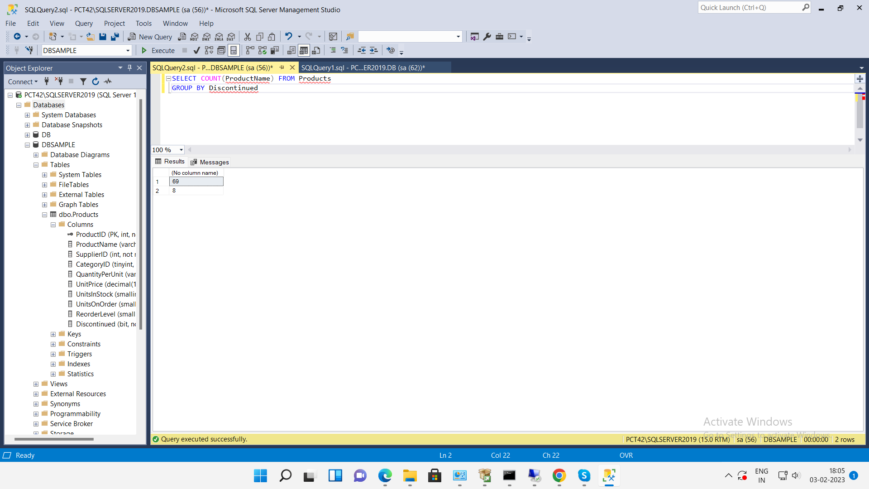

8. query to get Product list (name, units on order , units in stock) of stock is less than the quantity on order

